Experiment 36: Recognize an Object from an Image using General Object Recognition (Template Matching)
Software / Tools: Python · OpenCV (cv2)

AIM
To recognize/locate a known object (e.g. a watch) within a larger image using OpenCV's template matching technique.
ALGORITHM
1. Import OpenCV.
2. Read the main (source) image and the template image of the object to be found.
3. Apply cv2.matchTemplate() using a similarity method such as cv2.TM_CCOEFF_NORMED.
4. Use cv2.minMaxLoc() to find the location with the highest match score.
5. Draw a rectangle at the matched location using the template's width and height.
6. Display and save the image with the recognized object highlighted.
PROGRAM (SOURCE CODE)
import cv2

img = cv2.imread("scene.jpg")
template = cv2.imread("watch_template.jpg")
th, tw = template.shape[:2]

# Template Matching
result = cv2.matchTemplate(img, template, cv2.TM_CCOEFF_NORMED)
_, max_val, _, max_loc = cv2.minMaxLoc(result)

top_left = max_loc
bottom_right = (top_left[0] + tw, top_left[1] + th)
cv2.rectangle(img, top_left, bottom_right, (0, 0, 255), 3)

cv2.putText(img, f"Match: {max_val:.2f}", (top_left[0], top_left[1]-10),
cv2.FONT_HERSHEY_SIMPLEX, 0.6, (0, 0, 255), 2)

cv2.imshow("Recognized Object", img)
cv2.waitKey(0)
cv2.destroyAllWindows()

OUTPUT
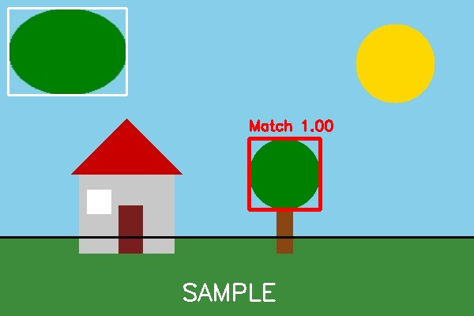
Fig. 36 — Output of Experiment 36: Recognize an Object from an Image using General Object Recognition (Template Matching).
RESULT
Recognize/locate a known object (e.g. a watch) within a larger image using OpenCV's template matching technique — completed successfully, as demonstrated in the output shown above.

